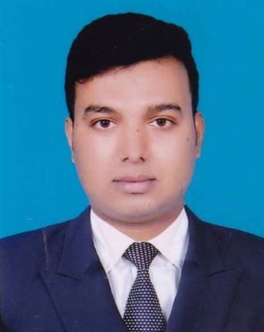

CURRICULUM VITAE

Md. Abdul-All-Noman

Sadar Upazilla Road, Indera para ,

Kushtia.

Cell: +8801757-774606

**E-mail: abdulallnoman94@gmail.com**

|  |  |
| --- | --- |
| OBJECTIVE | Looking for a dynamic and challenging job where I can enhance my potentiality in a development organization with my technical and interpersonal skills, in order to develop my career. |

|  |  |  |
| --- | --- | --- |
| PERSONAL  DETAILS | Name | Md. Abdul-All-Noman |
| Father's Name | Md. Abdul Halim |
| Mother's Name | Most.Rahana Parven |
| Present Address | Boro Bhabanipur, Kashimpur, Gazipur. |
| Permanent Address | Sadar Upazilla Road, Indera para ,  Kushtia. |
| Date of Birth | 17/06/1994 |
| Age | 26 years |
| Height | 5' 7′′ |
| Nationality | Bangladeshi (By Birth) |
|  | Marital Status | Married |
|  | Contact No. | (Self);+8801757-774606, +8801728-044649 (Home) |
|  | E-mail Address | [**abdulallnoman94@gmail.com**](mailto:abdulallnoman94@gmail.com) |

|  |  |  |  |  |  |
| --- | --- | --- | --- | --- | --- |
| ACADEMIC QUALIFICATION | | | | | |
| NAME OF DEGREE | GROUP/  SUBJECT/MAJOR COURSES | **INSTITUTE** | **YEAR OF PASSING** | DIVISION/ CGPA | BOARD/  UNIVERSITY |
| BSC in Engineering | EEE(Electrical & Electronics Technology) | European University Of  Bangladesh(**EUB**) | 2019 | 3.337out of 4.00(B+) | EUB, Dhaka |
| Diploma in Engineering | Electronics Technology | Kushtia Polytechnic Institute | 2015 | 2.82out of 4.00 (B) | BTEB, Dhaka |
| S.S.C. | Electrical | Technical School & Collage, Kushtia. | 2010 | 4.36out of 5.00 (A) | BTEB, Dhaka |

|  |  |
| --- | --- |
| COMPUTER LITERACY | * 6 Months Computer Tranning Course in TTC. * Internet-Web Browsing E-mailing. |

|  |  |
| --- | --- |
| EXPERIENCE | * Now I Work At Rancon Motor Bikes Ltd (RMBL),SUZUKI, From 03 rd November 2018 To Present. * 3 years Practical Experience as a Shift in Charge (Post Assembly) at Jamuna Electronics And Automobiles Ltd. * Completed 6 months training course of Electrical in Kushtia Youth Development Training Center, Kushtia. * Industrial Training on Bangladesh Telecommunication Corporation Limited(BTCL) for 12 weeks in Kushtia. * Industrial Training on Power Grid Company Of Bangladesh Limited(PGCB) for 08 weeks in,Jhenaidah at Kushtia 132/33 KV Grid Sub-Station. * 6 Months Palambing & Pipe Fitiengs Tranning Course in TTC.. * Completed 3 weeks training course of Mobile Phone Service in Kushtia Youth Development Training Center, Kushtia. |

|  |  |
| --- | --- |
| LANGUAGE PROFICIENCY | Good at Speaking and Writing Both in English and Bengali Medium. |

|  |  |
| --- | --- |
| OTHER QUALIFICATION | Working capability as a team, Convincing capability. |

|  |  |  |
| --- | --- | --- |
| REFERENCES | **Nazmul Imam**  News Editor  Jamuna Television Bhavon  Jamuna Future Park Complex ka -244,  ProgotiShoroni, Baridhara, Dhaka-1229.  Mob: 01714242633 | **DR.Rashel Ahamed**  B.C.S (Livestock)  Veterinary Surgeon(V.S)  Upazila Livestock Office  Bakergong,Barisal  Mobile No: 01723979300 |

(I hereby declared that the above information is correct)

Md.Abdul-All-Noman

Date. 19.08.2019 Signature